PARTICIPATING BIOBANKS

#*CHUM (Drs Mes-Masson/Provencher) | OHRI (Dr Vanderhyden)
*CHUS (Dr Piché) | OTB (Drs Bartlett/Hudson)
*CHUQ (Dr Bachvarov) | UHN Biobank (Dr Shaw)
*McGill (Dr Gotlieb) | UHN PBS (Dr Roehrl)
ACRB (Dr Johnston) | U. Manitoba (Dr Natchigal)
OvCare (Drs Huntsman/McAlpine) | TTR (Dr Watson)

# Coordinating centre
*Participants in the Réseau de recherche sur le cancer, Fonds de la recherche du Quebec-Santé.

COLLABORATORS

CONTACT

Project co-directors: Coordinator:

Dr Mes-Masson, CRCHUM, Montreal, Dr Cécile Le Page
anne-marie.mes-masson@umontreal.ca cecilelepage@yahoo.ca
Dr Provencher, HND-CHUM, Montreal
diane.provencher.chum@ssss.gouv.qc.ca
Dr Huntsman, BCCA, Vancouver
dhuntsma@bccancer.bc.ca

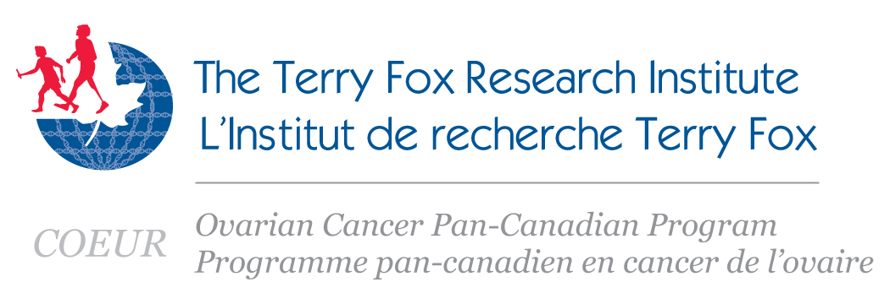

COEUR PROJECT DESCRIPTION

Ovarian cancer is the fifth-leading cause of cancer-related deaths in the western world. In one of every four women diagnosed, the cancer is resistant to standard first-line chemotherapy. In 2009, through TFRI, leading ovarian cancer researchers and clinicians across Canada have joined forces to develop a biomarker-driven subtype-specific management of ovarian carcinoma.

An essential component of the project is the creation of a Canadian Ovarian Experimental Unified Resource (COEUR). The aim is to address important clinical questions related to the care of ovarian cancer patients. This central platform establishes biological and data resources for the research community, and will help serve the entire biomarker program.

COEUR has been created to promote access, ensure quality, and provide standardization of material and data resources for biomarker research in ovarian cancer. COEUR will also facilitate biomarker research by promoting the translation of new findings into the clinical arena. This platform was developed on the principle that bio-specimens will be openly shared within the Canadian Ovarian Cancer Research Community based on approved studies.

This group effort will result in a new stratification system for ovarian carcinoma subtypes and will help clinicians provide tailored treatments for individual patients. In specific cases where patients do not respond to standard therapy, they could be directed to on going clinical trials where new therapies are being validated.

OBJECTIVES

- Develop a pan-Canadian validation platform for biomarker research.

- Use the biomarker platform to:
Develop a molecular-pathology classification system for ovarian cancer patients for clinical management.
Validate biomarkers that can be used in the stratification of ovarian cancer patients to provide for improved clinical prognosis.

- Articulate this correlative pre-clinical initiative with prospective clinical trials in order to expedite the translation of research findings to clinical practice.

ACCESS TO THE COEUR PLATFORM

COEUR is set up on the principle that biospecimens will be openly shared. Each investigator will have to complete an application form, which includes a study description. It is also central to the program, that study projects meet the management and study committee scientific criteria. Applicants will also need to provide a REB approval for their study and must be willing to deposit results and data in the COEUR repository at the end of the study.

For more information, please contact Cécile Le Page (cecilelepage@yahoo.ca).

QUALITY ASSESSMENT

Since the quality of samples is critical to the success of the program, member biobanks were audited in collaboration with the Canadian Tumour Repository network (CTRNet) to ensure the quality of materials and results have recently been published (Biopreserv. and Biobanking, 2013, pp83-93, “Specimen Quality Evaluation in Canadian Biobanks Participating in the COEUR Repository”).

REPOSITORY

The central research platform is based on a pooled retrospective collection of human epithelial ovarian cancer biological material.

TISSUE MICROARRAYS AVAILABLE:

- Test cohort: 100 High Grade Serous Carcinoma.
This TMA is available by accelerated requests to the Study Committee in order to obtain primary validation to access to the large cohort of the COEUR.

- Cohort of 750 High Grade Serous carcinoma.

- Cohort of 100 Endometrioid carcinoma.
Cohort of 28 HGSC and 84 EC

- Cohort of 100 Clear Cells Carcinoma.

- Cohort of 100 Mucinous carcinoma and LGSC (in progress)

Inclusion criteria: no borderline tumours, minimum 12 months follow-up, no pretreatment with chemotherapy before ovarectomy, no other concomitant cancers.

All TMA are reviewed by an expert gynecological-oncological pathologist.

The research platform also includes collections of human biological material, i.e frozen tissues, blood DNA, serum, plasma, ascites fluids, FFPE samples and TMA, with associated clinical data.

HOW TO ACCESS THE REPOSITORY

To access the COEUR repository, please contact the study committee or the project coordinator (cecilelepage@yahoo.ca).

